

|  |  |
| --- | --- |
| **NAME** | **AARYAN SINHA** |
| **ROLL NUMBER** | **20051796** |
| **SECTION** | **CSE-17** |
| **ASSIGNMENT NUMBER** | **7** |
| **ASSIGNMENT TOPIC** | **STATIC_AND_ARRAY** |

**START**

**QUESTION 1:-** Create a class SavingsAccount. Use a static variable annualInterestRate to store the annual interest for all accounts holders. Each object of the class contains a private data member savingsBalance indicating the amount of saver currently has on deposite and an account number. Provide a function calculateMonthlyInterest to calculate the monthly interest by multiplying the savingsBalance by annualInterestRate divided by 12 , this interest should be added to savingsBalance.Provide a static function modifyInterestRate that sets annualInterestRate to a new value.Write a program to test the class SavingsAccount.Set the annualInterestRate to 4%,then calculate the monthly interst and show the balance of the saver.Then set annualInterestRate to 5% and repeat the above calculation.

* **CODE FOR QUESTION 1:-**

class Interest_rate

{

static double annualInterest;

double savingsBalance;

long accountNumber;

Interest_rate(double annualInterest, double savingsBalance, long accountNumber)

{

this.annualInterest=annualInterest;

this.savingsBalance=savingsBalance;

this.accountNumber=accountNumber;

}

double calculate_Monthly_Interest()

{

double monthly_interest;

monthly_interest = (savingsBalance * annualInterest)/(12*100);

savingsBalance += monthly_interest;

return monthly_interest;

}

static void modify_Interest_Rate(double new_rate)

{

annualInterest=new_rate;

}

void display()

{

System.out.println("Therefore the annualInterest receiving is " +annualInterest);

System.out.println("Current savingsBalance is "+savingsBalance);

System.out.println("Account Number is " +accountNumber);

System.out.println("-------------------------");

System.out.println("The monthly_interest recieving is "+calculate_Monthly_Interest());

System.out.println("-----------------");

System.out.println("The updated savingsBalance is "+savingsBalance);

}

}

public class savings_account {

public static void main(String[] args)

{

System.out.println("-----------------------");

System.out.println("For 4% the interest rate will be");

Interest_rate i1=new Interest_rate(4,5000,20051796);

i1.display();

System.out.println("-----------------------");

System.out.println("For 5% the interest rate will be");

Interest_rate i2=new Interest_rate(5,5000,1110238);

i2.display();

}

}

* **OUTPUT FOR THE QUESTION 1:-**

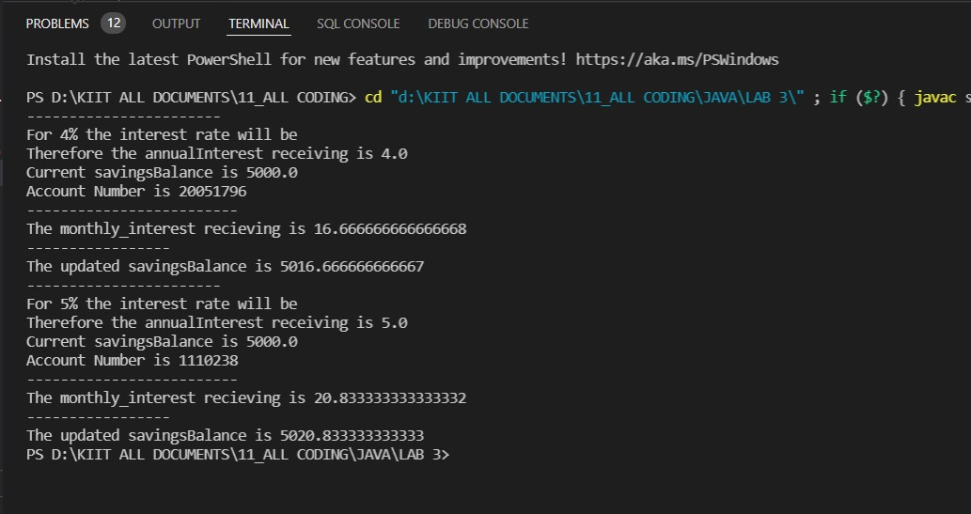

* **QUESTION 2:-** WAP to display all the command line arguments.

**CODE FOR QUESTION 2:-**

class Comd

{

public static void main(String args[])

{

for(int i=0;i<args.length;i++)

{

System.out.println(args[i]);

}

}

}

* **OUTPUT FOR THE QUESTION 2:-**

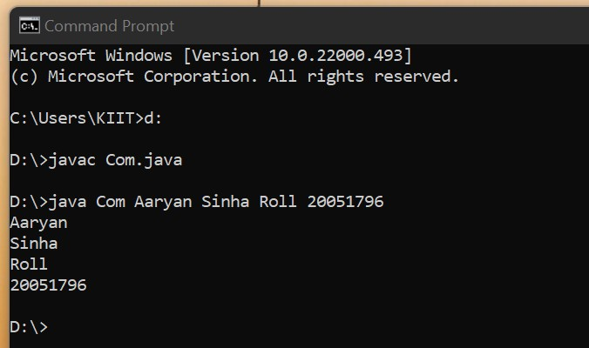

* **QUESTION 3:-**WAP to keep the data in a 2-D array value[3][4] and also display the content of array on console.
* **CODE FOR QUESTION 3:-**

import java.util.Scanner;

public class array_2d {

public static void main(String [] args)

{

System.out.println("Please Enter the size of row and column respectively");

int row,column;

Scanner input= new Scanner(System.in);

row= input.nextInt();

column=input.nextInt();

System.out.println("Please enter the elements inside the 2_d array");

int array_2d[][]=new int[row][column];;

// 3 is for rows and 4 is for columns

for(int i=0; i<row; i++)

{

for(int j=0; j<column; j++)

{

array_2d[i][j]=input.nextInt();

}

}

System.out.println("-----------");

System.out.println("Output");

for(int i=0;i<row;i++)

{

for(int j=0;j<column;j++)

{

System.out.print(array_2d[i][j] +" ");

}

System.out.println();

}

}

}

* **OUTPUT FOR THE QUESTION 3:-**

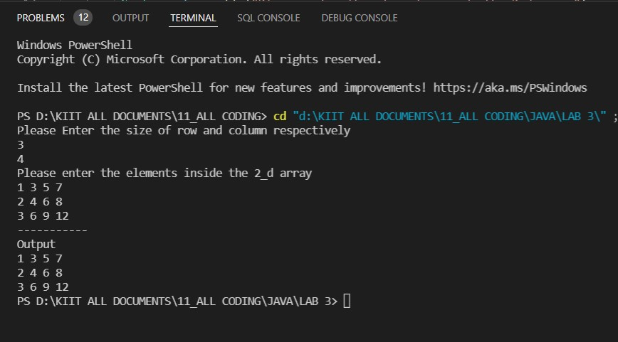

**END**